**A REPORT**

**ON**

**MEDIA INFLUENCE**

**AND**

**FAKE NEWS**

By:

K. Sai Ramashrita – 24FSSUCHH010018

Sri Lakshmi Prasanna – 24FSSUCHH010016

**ICFAI FOUNDATION FOR HIGHER EDUCATION**

**AUTHORIZATION**

We hereby declare that the project titled **"Media Influence and Fake news"** is a genuine work completed by us as part of the requirements for the BSc Psychology program at ISoSS Hyderabad, ICFAI Foundation for Higher Education.

This report showcases the original work done by the students, with consistent guidance and supervision provided by our faculty throughout the project.

**ACKNOWLEDGEMENT**

We would like to take this opportunity to express our sincere gratitude to everyone who has helped and supported us during the completion of this project titled **“Media Influence and Fake news”.**

First and foremost, We would like to thank our respected faculty guide, **Syed Hassan Abdullah Sir**, for the constant support, encouragement, insights and expert guidance. The feedback and suggestions were extremely valuable and helped us understand the subject better while working on this project.

We are also thankful to the university, **ICFAI Foundation for Higher Education**, for giving us the opportunity and resources to work on this project as part of our academic learning.

We would like to thank our friends and classmates who encouraged us and gave their honest opinions throughout the process. Their motivation kept us going.

Lastly, We are truly grateful to our families for their patience, motivation, and emotional support throughout this journey.

**TABLE OF CONTENTS**

Authorization

Acknowledgement

**1.** Introduction

**2.** Literature Review

**2.1** History Of Fake News And Media Influence

**2.2** Changes Over Time With The Rise Of Digital Media

**2.3** Current Status

**3.** Factors

**3.1** Causes

**3.2** Consequences

**3.3** Outcomes

**4.** Research Methodology

**5.** Findings

**6.** Solutions

**7.** References

**INTRODUCTION**

Media has always played an important role in shaping the way people understand and respond to events in society. Whether through newspapers, television, or digital platforms, the media has the power to inform, educate, and influence public opinion. With the rise of the internet and the growth of social media platforms such as Facebook, Twitter, Instagram, and YouTube, people today have instant access to information from around the world. However, this shift has also brought new challenges. One of the most serious among them is the spread of **fake news**—a term used to describe false, misleading, or entirely fabricated information presented in the form of legitimate news content.

The problem with fake news is not just that it exists, but that it spreads rapidly—often much faster than real news. This is largely due to the nature of digital media, where content is shared instantly, sometimes without checking the facts or the source. Social media algorithms are designed to promote content that gets more clicks, likes, and shares, which often favours sensational or emotional content over verified, factual reporting. Additionally, **echo chambers**—spaces where people only see opinions that match their own—make it easier for fake news to be accepted as truth. As a result, fake news can influence people’s beliefs and actions, impact political decisions, affect public health responses, and even damage reputations and businesses.

At the same time, the concept of **media influence** has become more complex. It no longer involves just the information being shared but also how that information is framed, who shares it, and how audiences interpret it. Media influence refers to the way news and content can shape perceptions, attitudes, and behaviours in both direct and subtle ways. In a world where anyone can create and share content, understanding how media works and how to navigate it responsibly is more important than ever.

As undergraduate students, we recognized the need to study this topic because fake news is not just a media problem—it is a social issue that affects everyone. Through this project, we aimed to explore how fake news spreads, how it affects the way people interact with information, and what can be done to reduce its impact. We also wanted to understand how much people trust different media platforms, how confident they are in spotting misinformation, and who they believe should be responsible for regulating content online. To support our study, we created a survey using Google Forms and shared it with people from different age groups and backgrounds, including students, teachers, and working professionals.

The overall goal of this project is to raise awareness about the effects of fake news, promote responsible media use, and highlight the importance of **media literacy**—the ability to critically analyze and evaluate information from various media sources. In a time where misinformation can easily go viral, we believe it is essential to build a society that can think critically, check sources, and understand the influence of media on everyday life.

**LITERATURE REVIEW**

**History of Fake News and Media Influence**

The concept of media influence has been studied since the early 20th century, beginning with the Hypodermic Needle Theory developed in the 1920s and 1930s. This theory suggested that mass media had a direct and powerful effect on passive audiences. At that time, traditional forms of media like newspapers and radio were dominant, and their reach gave them significant power to influence public opinion, especially during major events such as wars and political campaigns.

In the post-World War II era, new theories such as Agenda-Setting Theory (1972) and Framing Theory emerged. These models argued that while media may not directly change what people think, it strongly influences what people think about by highlighting certain issues over others. Throughout the 1980s and 1990s, media influence remained primarily shaped by professionally curated content from television, radio, and print journalism, all of which were regulated and followed editorial standards.

Although false information occasionally appeared in traditional media, it was relatively limited in scope due to editorial oversight and slower news cycles. Fake news during this time was mostly associated with political propaganda, satire, or biased reporting rather than widespread digital misinformation.

**Changes Over Time with the Rise of Digital Media**

The late 1990s and early 2000s marked a turning point in the way people consumed and shared information. With the development of the internet and the rise of Web 2.0 around 2004, users were no longer just consumers of content but also producers. Platforms like YouTube (launched in 2005), Facebook (2004), and Twitter (2006) allowed people to share news instantly with large audiences.

The term “fake news” entered popular discourse especially during the 2016 U.S. Presidential Election, when it was discovered that many false stories were being circulated online to influence political opinion. A 2018 study found that false news stories were 70% more likely to be retweeted than true ones, mainly because they were more novel or emotionally engaging.

As algorithms began determining what content people saw on their feeds, users were often exposed only to opinions similar to their own, reinforcing beliefs and limiting access to opposing views. By 2020, research showed that over 60% of people received their news through social media, and many were unaware of whether the sources were credible. A significant concern also emerged over the role of bots and fake accounts in spreading misinformation, especially during elections and crises.

Over time, fake news has evolved from isolated incidents to a persistent feature of the digital media environment. Although users report high confidence in their ability to recognize fake news, multiple studies reveal that a large percentage still share misleading content unintentionally.

**Current Status**

As of 2023, fake news remains a widespread and growing issue in global media systems. A recent international survey conducted across 16 countries revealed that 85% of respondents are concerned about the impact of fake news on society. Additionally, 52% of people say they come across fake or misleading news daily or several times a week, particularly on platforms like Facebook, YouTube, Twitter/X, TikTok, and Instagram.

The level of trust in different media sources varies significantly. Traditional media such as television and newspapers continue to be more trusted, with trust levels between 55% and 60%, while social media platforms show much lower trust levels—ranging between 25% and 30%.

In terms of users’ self-perception, 20% of respondents say they are very confident in their ability to identify fake news, while 35% report being somewhat confident. However, 30% remain unsure, and 15% admit they have often believed or shared fake information before realizing it was false.

Another study conducted in 2023 among digital content creators found that 2 out of 3 influencers do not consistently verify the information they post, suggesting that the unchecked spread of information continues to be a major concern in today's digital culture.

**FACTORS**

**CAUSES**

**1. Social Media Algorithms and Filter Bubbles**

Social media platforms like Facebook, Twitter, and Instagram use complex algorithms to decide which posts show up in your feed. These algorithms prioritize content that gets a lot of engagement—such as likes, shares, and comments. This means that posts that are exciting, controversial, or emotionally charged, often including fake news, get more visibility. While this helps keep users engaged, it also creates what’s known as a filter bubble. This is a situation where a person only sees content that aligns with their existing beliefs. Over time, they stop encountering opposing viewpoints, and only information that reinforces their opinions appears. Because fake news is often emotionally engaging and sensational, it tends to spread rapidly in these bubbles.

**Quantitative Data:** A study found that false news stories are 70% more likely to be retweeted than true ones, primarily because fake news is often more novel or emotionally engaging.

**2. Echo Chambers and Homophily**

An echo chamber occurs when people surround themselves with others who share the same views and ideas. In these environments, people only hear information that confirms what they already believe. Homophily is the social phenomenon where people tend to associate with others who have similar views, values, or characteristics. This contributes to the creation of echo chambers. When individuals only hear from others who agree with them, it becomes easier for misinformation to spread because new or contradictory information is ignored or dismissed. People in these echo chambers become more resistant to changing their opinions, which makes it easier for fake news to take hold.

**Quantitative Data:** Research indicates that only about 4% of people are in these echo chambers, drawing the majority of their information from a narrow spectrum of partisan sources. However, these individuals are often highly politically active and influential, which means their beliefs can affect others, spreading extreme opinions.

**3. Confirmation Bias**

Confirmation bias is the tendency for people to seek out and believe information that supports their existing beliefs, while ignoring or rejecting information that contradicts them. This bias makes people more susceptible to believing and spreading fake news, especially if it aligns with their worldview. When people come across information that confirms their beliefs, they are more likely to accept it without questioning its authenticity. This psychological bias means that fake news is often shared widely because it fits into people's mental models of the world, without them considering whether it is true or not.

**Qualitative Insight:** Confirmation bias is a powerful force that drives the spread of fake news. When people see content that agrees with their views, they are less likely to investigate whether it’s accurate. Instead, they will share it with others, reinforcing the false information.

**4. Information Overload and Rapid Sharing**

In the digital age, people are bombarded with a constant flow of information. There is so much content available online that it becomes overwhelming to figure out what’s credible and what’s not. This "information overload" leads to people making quick decisions about what to share without verifying its accuracy. The rapid pace of social media means that people often share content immediately, often just because it looks interesting or sensational. Since fake news is often designed to be eye-catching or shocking, it spreads quickly before anyone has time to check its truthfulness.

**Qualitative Insight:** The sheer amount of information on social media means that people are likely to share things based on emotional reactions, not on thoughtful evaluation. This rapid sharing of unverified content contributes to the spread of fake news, as users prioritize speed over accuracy.

**5. Automated Bots and Fake Accounts**

Bots are automated software programs designed to mimic human behaviour on social media. These bots are often used to promote fake news by posting and sharing it at an extremely high rate. They can make a piece of fake news appear more popular than it actually is by spreading it to a wide audience quickly. Fake accounts, which are controlled by real people, can also be used to amplify fake news. These fake accounts interact with others to create the illusion of credibility, making it seem as though many people believe the misinformation. This manipulation of online social networks makes it harder for users to trust what they see and can lead them to believe false information.

**Quantitative Data:** An analysis of 14 million messages spreading 400,000 articles on Twitter during the 2016 U.S. presidential campaign found that social bots were disproportionately responsible for spreading low-credibility content. Bots played a major role in amplifying fake news.

**6. Trust in Social Media as a News Source**

Even though many people are aware of the problems with fake news on social media, a lot of people still turn to social media for their news. Social media platforms are convenient and fast, but they don’t have the same editorial standards or fact-checking systems as traditional news sources like newspapers or TV. This creates a paradox: people know that fake news is common, but they continue to trust social media for information. Because social media is often the easiest and quickest way to get news, many people ignore the risks of misinformation, which helps fake news spread.

**Quantitative Data:** According to a UNESCO-Ipsos survey, 64% of urban Indians identified social media as the biggest source of fake news. Yet, despite knowing about the spread of fake news, 56% still use social media as their primary source of news and information.

You can use a pie chart to illustrate the sources of fake news. Here’s a breakdown based on your data:

* Social Media Feeds: 64%
* Online Messaging Groups: 42%
* Media Websites/Apps: 23%
* Television: 17%
* In-person/Online Discussions: 17%
* Newspapers/Magazines: 11%
* Radio: 4%

This chart helps clearly visualize how social media is seen as the biggest source of fake news, while other sources contribute less significantly.

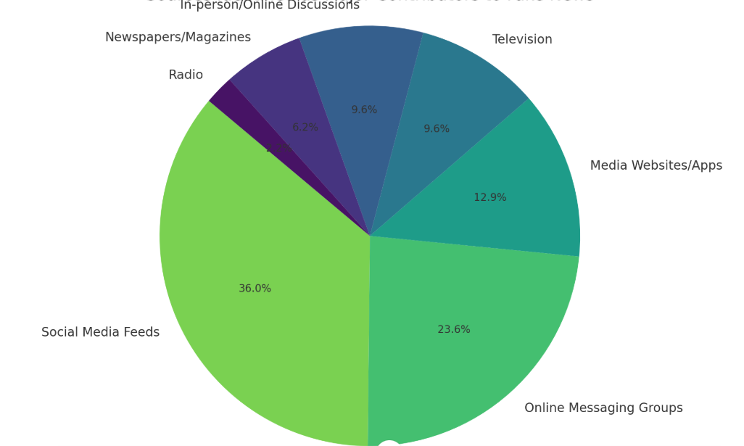

**CONSEQUENCES**

**1. Misinformed Public**

Fake news spreads false or misleading information that people often accept as true. This misinformation shapes public opinion in the wrong direction and influences important decisions on health, politics, science, and society. Since many people don't verify the facts, they become misinformed and make poor choices.

**Example**: During the COVID-19 pandemic, fake news about home remedies or vaccine myths made people avoid proper medical treatment.

**2. Social and Political Polarization**

Fake news can widen gaps between different groups in society. It often plays on religious, political, or cultural differences and presents one side as “good” and the other as “bad.” This creates hatred, reduces tolerance, and makes peaceful discussions difficult. People begin to see others who disagree with them as enemies.

**Example:** Fake political posts can make people hate or fear those who support another party or opinion, leading to intense online and offline arguments.

**3. Threat to Democracy**

A democracy functions properly only when citizens are well-informed. Fake news disrupts this by misguiding voters, damaging political reputations, and spreading propaganda. It can be used to manipulate people’s choices, especially during elections, which affects the fairness of the democratic process.

**Example:** False stories about candidates during elections can affect voting decisions and reduce trust in the political system.

**4. Damage to Reputations**

When someone is wrongly accused or misrepresented in fake news, their public image is severely harmed. Even if the truth comes out later, the damage is often already done. Careers may end, businesses may lose customers, and people may suffer mentally and emotionally.

**Example:** A celebrity falsely accused of a crime in fake news may face public backlash, even after the truth comes out.

**5. Public Panic and Fear**

Fake news often spreads fear by exaggerating or inventing threats—like false warnings about bomb blasts, diseases, or crimes. This creates panic in public places, causing chaos and even injuries. It also wastes the time and resources of emergency services.

**Example:** Fake news about a bomb scare in a mall can cause chaos, even if it’s completely untrue.

**6. Economic Consequences**

Fake news can lead to financial losses for businesses, industries, and even governments. Rumours about product quality, company failures, or market crashes can influence consumer behaviour and investor decisions. These economic effects often hit small businesses and common people the hardest.

**Example:** A false rumour about a company’s bankruptcy can cause its stock prices to fall drastically, affecting investors and employees.

**7. Undermining Trust in Real News**

When fake news becomes common, people start doubting all types of information. This includes verified news from reliable media and government sources. As a result, this creates confusion and reduces overall trust in journalism and media.

**Example:** If people regularly see fake headlines, they might start questioning all news—even verified reports from reliable media outlets.

**8. Impact on Mental Health**

Constant exposure to alarming or misleading fake news - especially when it’s negative, frightening, or exaggerated - can cause stress, anxiety, or hopelessness, especially during crises like pandemics or wars.

**Example:** People reading fake news about constant threats may feel scared, anxious, or overwhelmed, even when the danger isn't real.

**OUTCOMES**

The outcome of this project is that we have gained a better understanding of how fake news affects society, including its impact on politics, health, the economy, and mental well-being. We've developed important skills like critical thinking and research, which help us evaluate the information we come across more carefully. Through exploring real-life examples, we’ve learned how fake news spreads and how it can influence people's beliefs and behaviours. This project has also taught us the value of media literacy—the ability to tell whether information is reliable or not. We now know how to recognize misinformation and are more aware of its risks. Finally, this project has helped us improve our communication skills, which will be useful in both our studies and future careers. It’s also given us a sense of responsibility in the way we consume and share information.

**RESEARCH METHODOLOGY**

This study employed a mixed-methods research approach, integrating both quantitative and qualitative methodologies to gain a comprehensive understanding of media influence and the spread of fake news. Quantitative data was collected through structured surveys, allowing for the analysis of patterns and trends across a larger population. In addition, qualitative insights were gathered through in-depth interviews, which provided nuanced perspectives and deeper contextual understanding of individuals’ experiences and perceptions related to media consumption and misinformation.

**Data Collection Methods:**

We adopted a mixed-methods approach combining:

* Quantitative: Google Forms survey with 145 respondents (public)
* Qualitative: 5 in-depth interviews with media professionals

**Research Locations**

* National/regional newspaper offices
* Television broadcast stations (newsrooms and production centers)
* Twitter/X Spaces
* International fact-checking networks
* Street Vendor Hubs (newsstands, food carts)

**Sample Size:**

Survey Respondents (n=146)

**Sample Demographics:**

* Age: 16 to 40+ years
* News Consumption (Global Average): Daily ( 60% ), Weekly ( 25% ), Occasionally( 10% ), Rarely( 5% )
* Occupation: Students, Print media professionals,Electronic media professionals, Homemakers, IT professionals, Vendors

**Questionnaire (Quantitative Data Collection)**

**Sample Questions & Responses**:

1. *"*How often do you encounter fake news?"
   * Daily: **20%** | Weekly: **40%** | Occasionally: **28%** | Rarely: **15%**
2. *"*Which platform spreads the most fake news?*"*
   * YouTube: **33%** | Instagram: **35%** | Facebook: **13%**
3. *"*Rate fact-checking effectiveness (1–5)."
   * 4–5 (Very effective): **28%**
   * 3 (Somewhat effective): **43%**
   * 1–2 (Ineffective): **23%**

**Interview Questions (Qualitative Data Collection)**

**Sample Questions**

1. Do you think fake news is a bigger problem now than before? Why?
2. How do you cover impartiality when covering politically sensitive topics?
3. Can you give an example of a case where fake news caused significant harm?
4. Do you think AI will make fake news harder to detect?
5. What’s the change needed in the industry to combat fake news effectively?

**FINDINGS**

**Quantitative Data Collection**

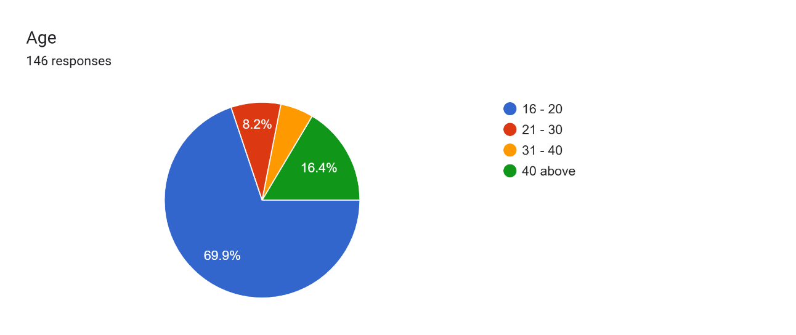

Forms response chart. Question title: Where do you primarily get your news from?
. Number of responses: 146 responses.

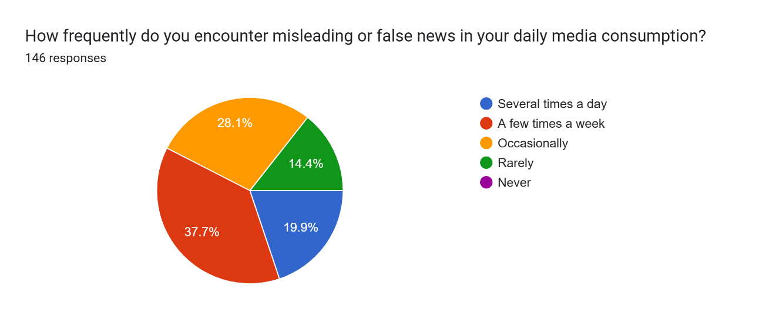

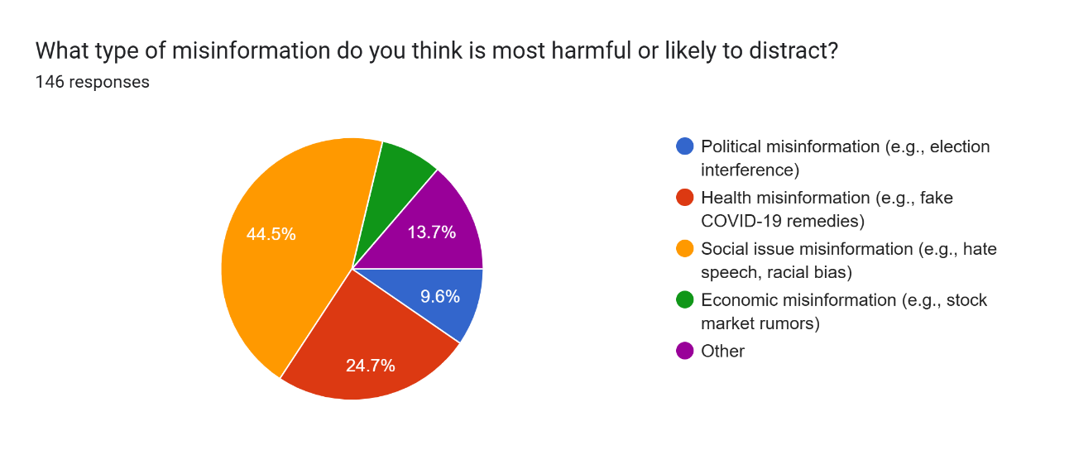

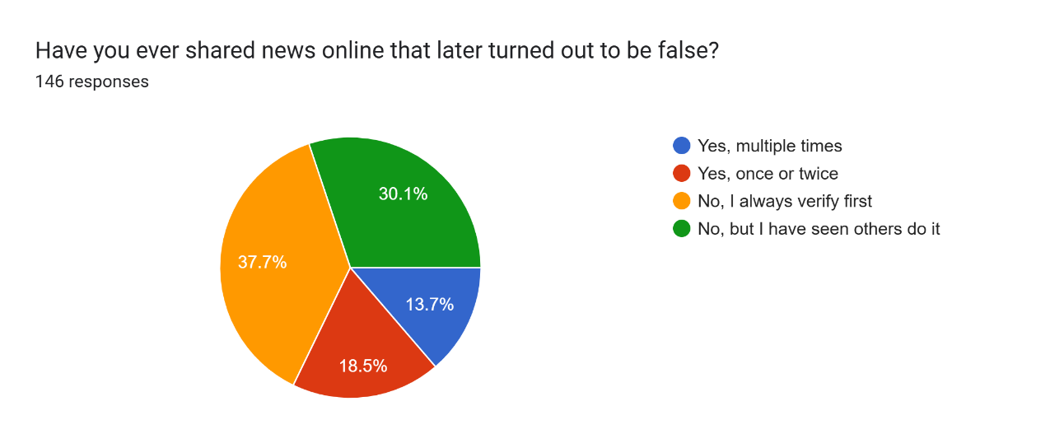

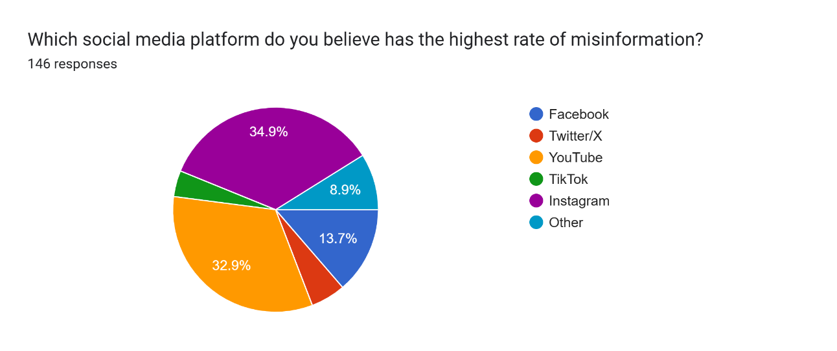

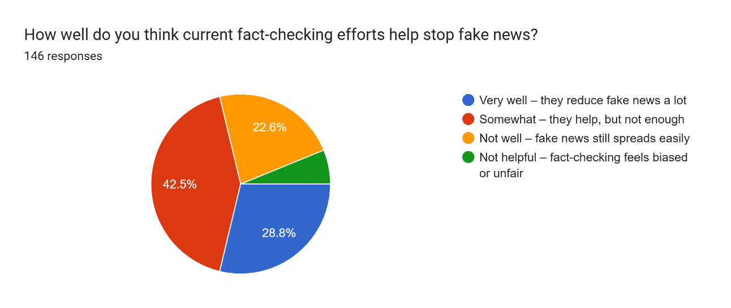

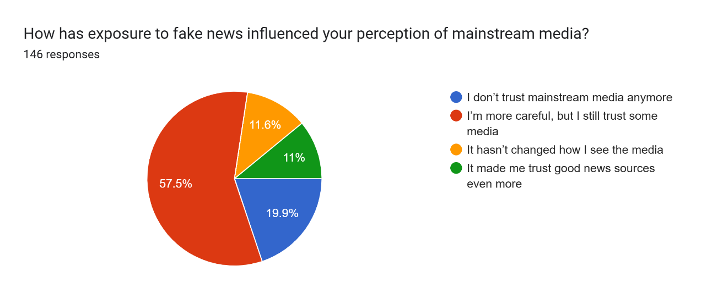

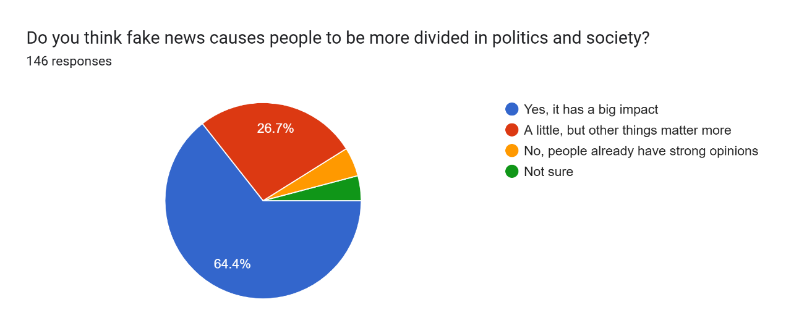

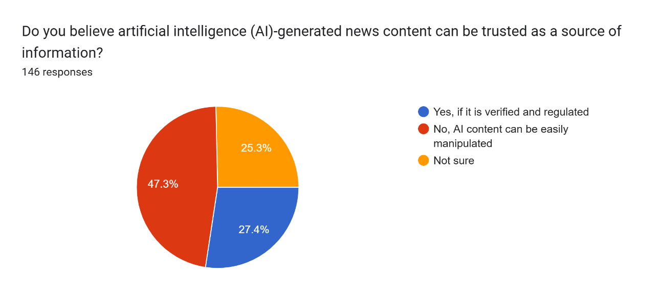

Forms response chart. Question title: What measures do you think are most effective in combating misinformation?
. Number of responses: 146 responses.

As a journalist or news consumer, have you noticed a decline in trust in traditional media over recent years? If yes, why? **(92 responses)**

**Sample Responses:**

* “It is mostly because of the political influence on the media channels which leads to pushing of propaganda and also covering up major issues to benefit certain parties which has lead to a decline in trust towards traditional media.” **(Age: 16 - 20)**
* “Yes, Platforms like Twitter, YouTube, and independent blogs give people access to a wider range of perspectives. Some now prefer these sources, viewing them as more authentic or unfiltered.” **(Age: 16 - 20)**
* “Yes ….. The past few years have seen social media's reputation increasingly mired by a myriad of issues ranging from misinformation and fake news to concerns about transparency, polarisation, cyberbullying, and child safety – the list goes on.” **(Age: 31 - 40)**
* “Not sure. But I feel the statistics are sometimes true and sometimes false. Say if any accidents take place and we still do not know how many people are actually in danger or how many have already died. They just provide misinformation I feel and coming to abuses, assaults and harassments most of the cases remain hidden and never comes to the light. Idk if they're doing it for protecting someone's life or someone's position in the society. This creates a decline in trust in traditional media.” **(Age: 16 - 20)**
* “Media has become revenue model, no more social responsibility.” **(Age: 40 above)**

How can schools or universities help students spot fake news better?  **(84 responses)**

**Sample Responses:**

* “Integrate media literacy into the curriculum to teach students how to critically evaluate news sources, check facts, and identify bias, propaganda, and misinformation.” **(Age: 16 - 20)**
* “Creating awareness among all students how fake news spread across the world within no time. It is our duty to curb it and raise the voice against such fake news.” **(Age: 40 above)**
* “In our schools, they used to make sure every student got a newspaper daily during morning break to bring a habit of reading the newspaper, as now everything is digitalized teachers can provide students with trusted web sources regarding daily news information.” **(Age: 16 - 20)**
* “Providing awareness programmes if possible it should be added to their curriculum” **(Age: 21 - 30)**
* “Incorporate ethical values during study period and making students to understand the importance of value based reporting.” **(Age: 40 above)**
* “Self check before forwarding, relying on the trusted source only, self awareness is necessary” **(Age: 31 - 40)**

**Qualitative Data Collection**

**Q.** How does fake news affect individuals and society?

**Response:**  
"Fake news often causes emotional reactions, influences public opinion, and can even lead to social unrest. It targets people's trust and affects their belief systems."

**Q.** How has the media landscape changed over time in terms of credibility and information flow?

**Response:**  
"There has been a shift from well-established news outlets like newspapers, radio, and TV to quick digital sources. After 2012-13, the digital boom allowed everyone to become a content creator without checks and balances."

**Q.** What are the challenges in identifying and stopping fake news?

**Response:**

* Lack of verification mechanisms
* Quick consumption habits of audiences
* No clear responsibility over content verification
* People do not often cross-check sources

**Q.** What has led to the increase in fake news in recent years?

**Response:**  
"The digital revolution and political campaigns post-2009 (Obama) and 2014 (Modi) have played a role. More people started consuming digital news without filters, and there’s no effective mechanism to verify what they read."

**Q.** What do you think is the psychological impact of fake news?

**Response:**  
"Fake news creates confusion and fear, making people anxious or angry. It divides communities by playing on emotions and spreading misinformation, which reduces trust in the media and important institutions."

**Q.** What steps can be taken to make people more aware of fake news?

**Response:**  
"Media literacy should be taught from school level. Public awareness campaigns can help people distinguish between real and fake news. Encouraging individuals to verify content before sharing is crucial."

**SOLUTIONS**

**1. Media Literacy Education**

* Why it matters: A major cause of fake news spread is the public’s limited ability to distinguish between reliable and misleading sources.
* Solution: Promote media and digital literacy programs starting from schools and colleges. These programs should teach students how to:
  + Evaluate sources,
  + Recognize bias,
  + Understand clickbait and sensationalism.
* UNESCO-Ipsos Finding: 68% of respondents agreed that better media literacy would help limit the spread of disinformation.

**2. Strengthening Fact-Checking Mechanisms**

* Why it matters: Fake news spreads faster than the truth, especially on digital platforms.
* Solution:
  + Support verified, independent fact-checking bodies.
  + Encourage use of real-time verification tools and encourage users to cross-check before sharing.
  + Train journalists and media staff in digital forensics.
* Example: AltNews, BOOM, and Factly in India are already doing vital work in this area.

**3. Parallel Campaigning**

* Purpose: Actively challenge fake news by running truth-based campaigns alongside misinformation trends.
* Action:
  + Launch parallel awareness campaigns when a specific fake news trend starts circulating.
  + Use platforms where fake news spreads (WhatsApp, YouTube, Facebook) to counter it with verified facts.
  + Ensure quick response from news outlets to neutralize viral falsehoods.
* Note: This method prevents fake narratives from gaining momentum and redirects public attention to reality.

**4. Responsible Journalism & Regulation**

* Why it matters: Lack of editorial responsibility contributes to the distribution of fake content, especially through fringe media.
* Solution:
  + Implement stronger ethical guidelines in newsrooms.
  + Strengthen editorial standards and accountability.
  + Encourage transparency about sources.
* UNESCO-Ipsos Data: Only 51% of people trust traditional media to be accurate, which reflects a need for more credibility.

**5. Platform Accountability**

* Why it matters: Social media plays a central role in viral misinformation.
* Solution:
  + Platforms like Facebook, Twitter, and WhatsApp must be legally obligated to moderate harmful content.
  + Algorithms should be revised to reduce promotion of misleading or emotionally manipulative content.
* BBC Trending Article Insight: WhatsApp was a major driver of fake news during the 2019 Indian elections, due to uncontrolled forwarding of messages.

**6. Public Awareness Campaigns**

* Why it matters: Not everyone knows how to identify fake news.
* Solution:
  + Use TV, FM radio, and social media to launch awareness campaigns.
  + Promote slogans like *"Think Before You Share"* or *"Verify Before You Trust."*
  + Celebrate Global Media and Information Literacy Week to involve citizens.
* UNESCO-Ipsos: Only 27% of respondents reported having received any formal training on identifying fake news.

**7. Government Regulations and Policies**

* Why it matters: Legal ambiguity allows fake news creators to operate freely.
* Solution:
  + Governments should pass clear anti-disinformation laws.
  + Enforce penalties for creators of fake news and misinformation campaigns.
  + Collaborate with international bodies to regulate cross-border disinformation.

**8. User Empowerment Tools**

* Purpose: Allow individuals to verify content independently.
* Action:
  + Promote tools like browser extensions, reverse image searches, fact-check apps, etc.
  + Train users in basic digital literacy through mobile-based platforms.
  + Tools like NewsGuard, InVID, Google Fact Check Explorer can help users validate news.
* Technical Research (ACM India): Suggests AI tools for real-time misinformation detection could be integrated with platforms.

**9. Collaboration with Journalists and Researchers**

* Why it matters:- Collective efforts produce better long-term solutions.
* Solution:
  + Encourage cross-sector partnerships between tech companies, journalists, researchers, and educators.
  + Support studies on behavioural trends in misinformation sharing to develop better strategies.

**REFERENCES**

1. UNESCO & Ipsos. (2023). *Survey on the impact of online disinformation and hate speech*. Retrieved from <https://www.unesco.org/sites/default/files/medias/fichiers/2023/11/unesco_ipsos_survey.pdf>
2. BBC Bitesize. (n.d.). *What is fake news?* Retrieved April 17, 2025, from <https://www.bbc.co.uk/bitesize/articles/zwcgn9q>
3. BBC News – Trending. (2018, January 19). *The (almost) complete history of 'fake news'*. Retrieved from <https://www.bbc.com/news/blogs-trending-42724320>
4. Journalist’s Resource. (2023, February 1). *Fake news and conspiracy theories: The role of journalists and researchers in countering misinformation*. Harvard Kennedy School. Retrieved from <https://journalistsresource.org/politics-and-government/fake-news-conspiracy-theories-journalism-research/>
5. Sundar, S. S., & Vadrevu, S. (2022). *Fake news in India: Challenges and opportunities for researchers and policymakers*. *Communications of the ACM*, 65(7), 52–56. Retrieved from <https://cacm.acm.org/research/fake-news-in-india/>
6. Alt News. (n.d.). *Fighting misinformation one fact-check at a time*. Retrieved from <https://www.altnews.in/>
7. BOOM. (n.d.). *Verified fact-checking in India*. Retrieved from <https://www.boomlive.in/>